Software Quality Assurance (SQA) – 3RD Week Project Task
Name: Jaweria Kamran DHC (4521)S

Project Title: Testing of Daraz E-Commerce Website

Automate at least two test cases:

Login or Signup Validation:

Objective: Verify that a user can log in or sign up successfully with valid credentials.
- Steps (Manual):
- Open the browser and navigate to the website.
- Click on Login or Signup.
- Enter valid username/email and password.
- Click on Submit/Login.
- Check if user is redirected to the dashboard/home page.

Selenium Python Example:
from selenium import webdriver
from selenium.webdriver.common.by import By
from selenium.webdriver.common.keys import Keys
import time

# Step 1: Launch browser
driver = webdriver.Chrome() # Make sure chromedriver is installed
driver.get("https://www.daraz.pk/login") # Replace with your website URL
driver.maximize_window()

# Step 2: Enter login credentials
driver.find_element(By.ID, "username").send_keys("Jaweria Kamran")
driver.find_element(By.ID, "password").send_keys("Moon@#00")

# Step 3: Click Login button
driver.find_element(By.ID, "loginButton").click()
time.sleep(3) # Wait for page to load

# Step 4: Verify successful login
if "Dashboard" in driver.title:
print("Login Test Passed ✅")
else:
print("Login Test Failed ❌")

# Step 5: Close browser
driver.quit()

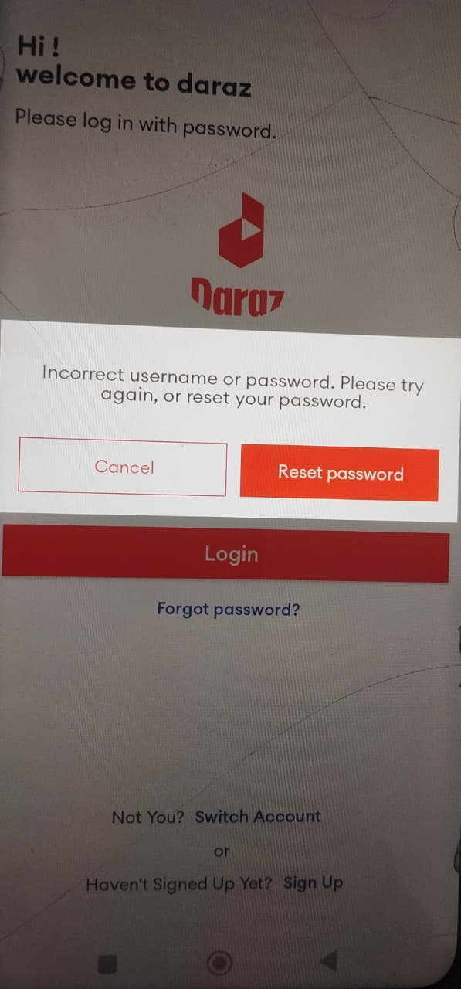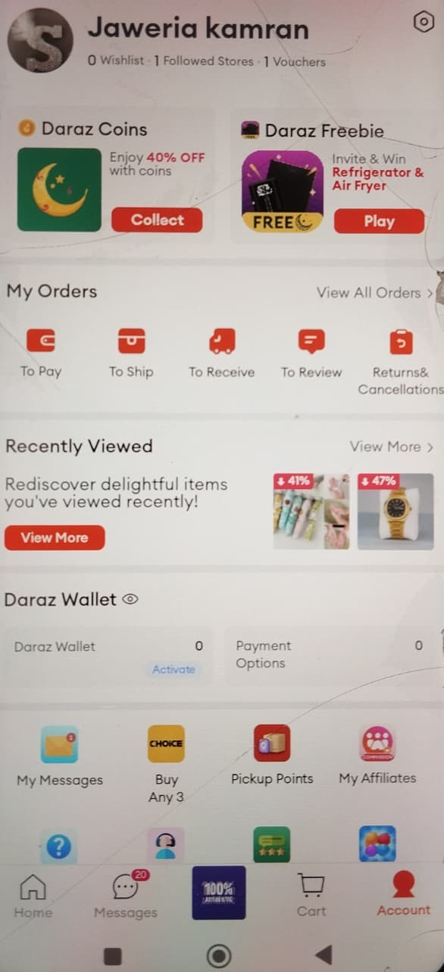

Feature or Dashboard Functionality Test:
- Objective: Verify that dashboard features (like adding a new item, clicking buttons) work correctly after login.
- Steps (Manual):
- Login to the application (reuse login test).
- Navigate to Dashboard/Feature page.
- Perform a feature action (like clicking Add Item, filling a form).
- Verify that the action is successful (item appears in list, confirmation message).
Selenium Python Example:
from selenium import webdriver
from selenium.webdriver.common.by import By
from selenium.webdriver.common.keys import Keys
import time

# Step 1: Launch browser
driver = webdriver.Chrome() # Make sure chromedriver is installed
driver.get("https://www.daraz.pk/login") # Replace with your website URL
driver.maximize_window()

# Step 2: Enter login credentials
driver.find_element(By.ID, "username").send_keys("Jaweria Kamran")
driver.find_element(By.ID, "password").send_keys("Moon@#00")

# Step 3: Click Login button
driver.find_element(By.ID, "loginButton").click()
time.sleep(3) # Wait for page to load

# Step 4: Verify successful login
if "Dashboard" in driver.title:
print("Login Test Passed ✅")
else:
print("Login Test Failed ❌")

# Navigate to dashboard feature
driver.find_element(By.ID, "addItemButton").click()
time.sleep(1)

# Fill form to add item
driver.find_element(By.ID, "itemName").send_keys("New Feature Test")
driver.find_element(By.ID, "itemSubmit").click()
time.sleep(2)

# Verify item added
added_item = driver.find_element(By.XPATH, "//td[text()='New Feature Test']")
if added_item:
print("Dashboard Feature Test Passed ✅")
else:
print("Dashboard Feature Test Failed ❌")

driver.quit()
# Step 5: Close browser
driver.quit()

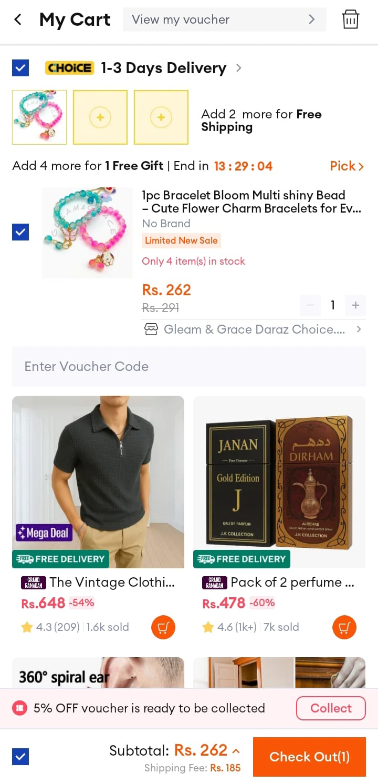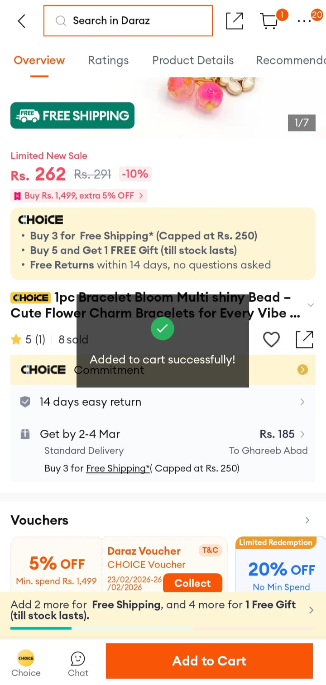

API Testing using Postman:
- Introduction:
- API (Application Programming Interface) allows different applications to communicate.
- API Testing ensures the endpoints work correctly and return expected data.
- Common HTTP Methods:
  - GET → Read data
  - POST → Create data
  - PUT → Update data
  - DELETE → Delete data
- Example API Testing:
- Assume we have a demo API: https://jsonplaceholder.typicode.com/users

a) GET Request – Read Users:
- URL: https://jsonplaceholder.typicode.com/users
- Method: GET
- Click Send → Check response
- Expected: List of users in JSON

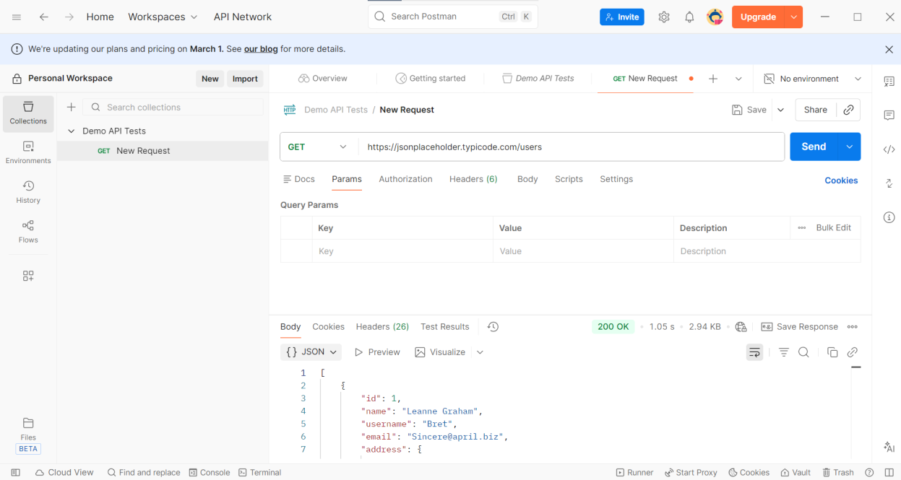

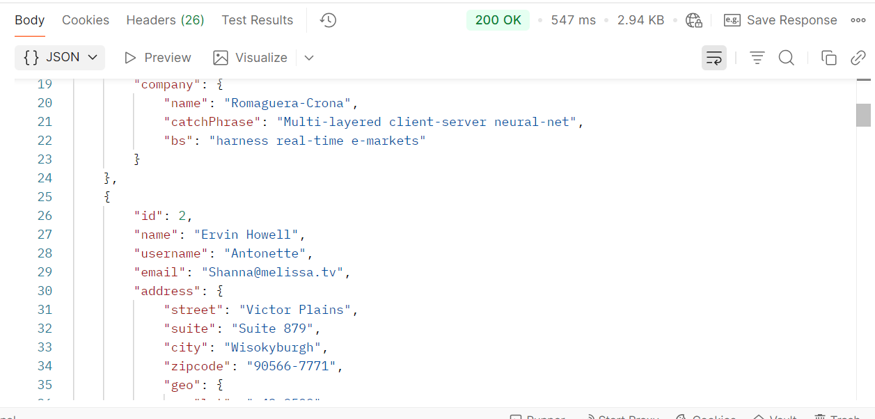

b) POST Request – Create User:
- URL: https://jsonplaceholder.typicode.com/users
- Method: POST
- Body → raw → JSON

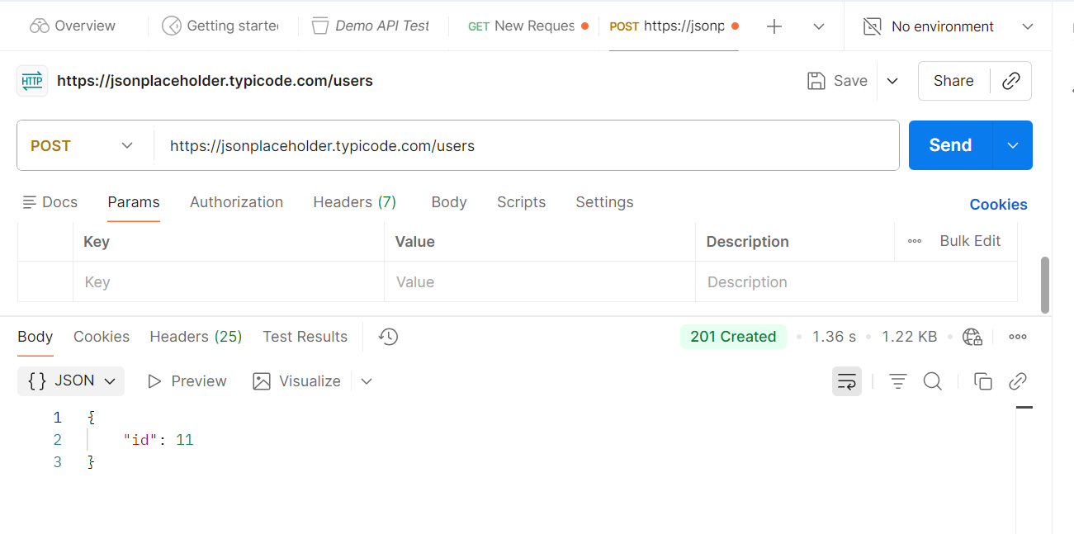

C ) PUT Request – Update User:
- URL: https://jsonplaceholder.typicode.com/users/1
- Method: PUT
- Body → raw → JSON

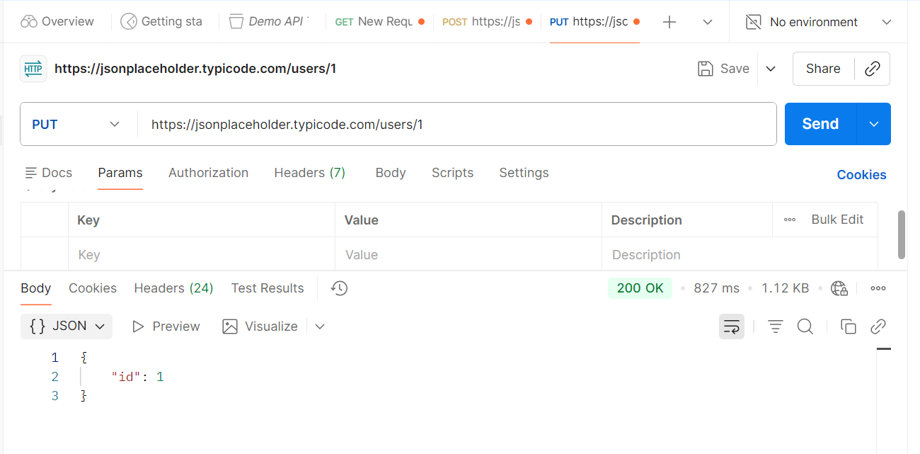

d) DELETE Request – Delete User:
- URL: https://jsonplaceholder.typicode.com/users/1
- Method: DELETE
- Click Send → Response should return 200 OK or 204 No Content.

